**CI/CD Handson**

**Creating CodeStar Project**

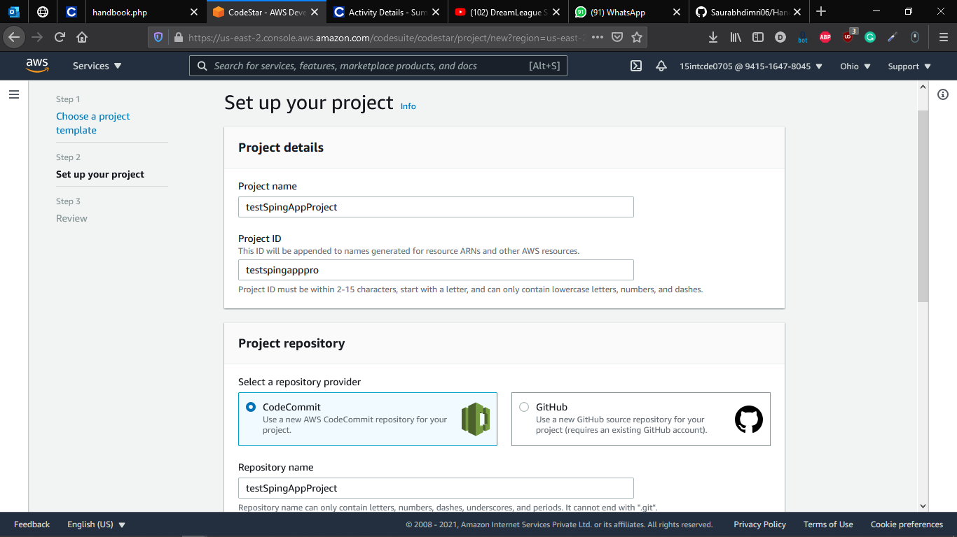

**Pipeline Executed**

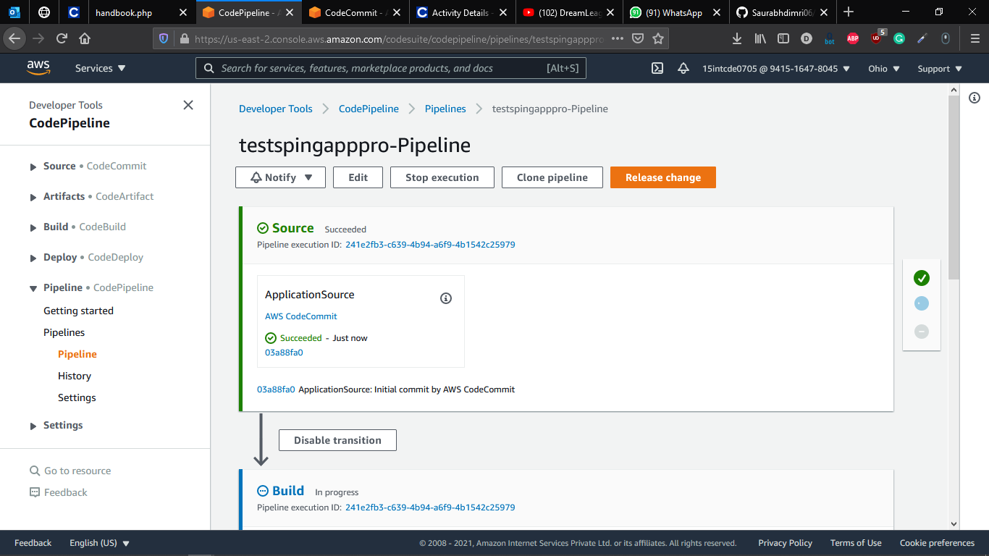

**Succeeded Pipeline**

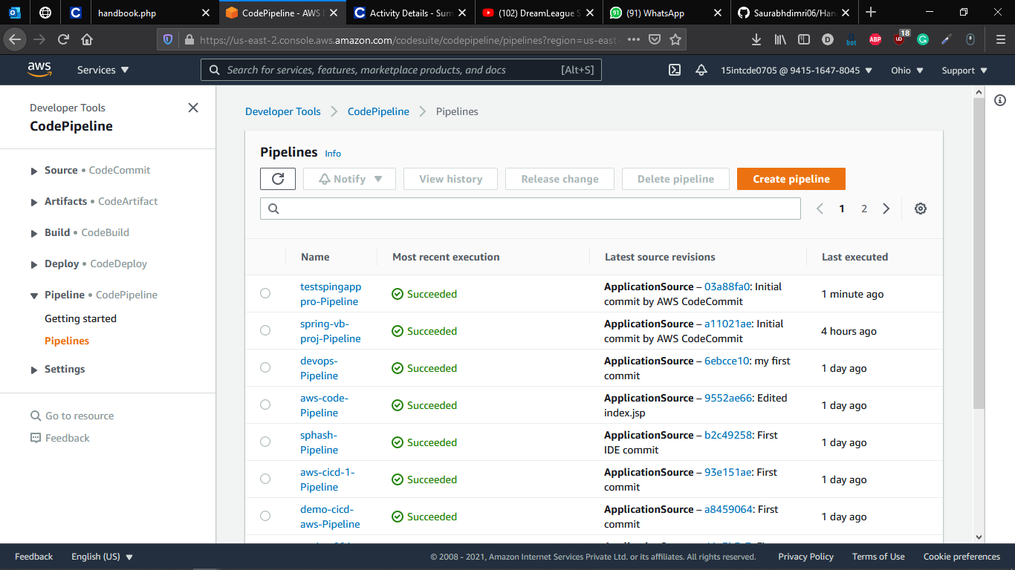

**Creating Cloud 9 Environment**

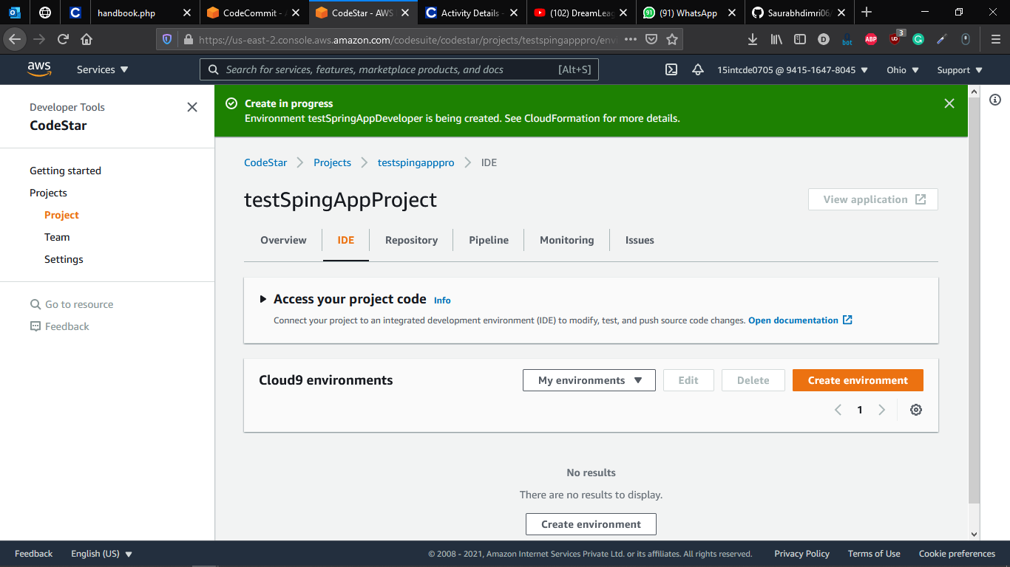

**Editing the Code in Cloud9**

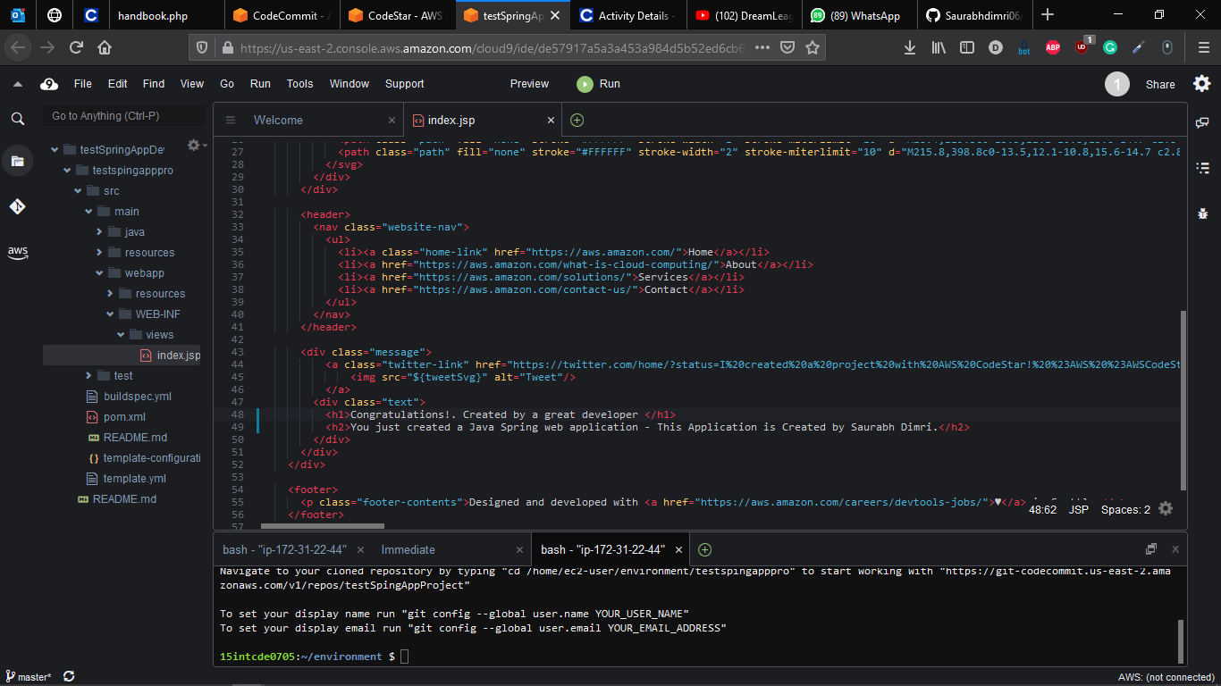

**Successfully Triggering the Pipeline via the new Push**

